

HRPP Newsletter

March 2026



NEWS YOU CAN USE
- When to Complete Section 6.0 in the HRP 503 Protocol Template: When completing the HRP 503 Protocol Template, investigators often ask whether Section 6.0 (Data and Specimen Banking) is required. While section 19 is always required, the key distinction on when section 6 is needed is whether your study is creating a data or specimen bank for future use.

  - Use Section 6.0 – Data and Specimen Banking: Complete Section 6.0 only if your study involves storing data and/or biological specimens for future, unspecified research use beyond the current study. This includes situations where data or specimens will be:
    - Retained after the study ends for future research questions
    - Shared with other researchers or used in future studies
    - Maintained as part of a formal or informal “bank” or repository
If this applies, Section 6.0 should describe what will be stored, where and how it will be stored, how long it will be retained, who will have access, and how data or specimens may be released.

  - Use Section 19 – Data Management and Confidentiality (Only): If your study is not creating a data or specimen bank, and data or specimens are collected solely for the purposes of the current study, you do not need to complete Section 6.0. In these cases, you should:
    - Mark Section 6.0 as Not Applicable, and
    - Fully describe data handling, storage, security, access, retention, and confidentiality protections in Section 19 – Data Management and Confidentiality.
Most studies—including surveys, interviews, behavioral research, and studies where data are destroyed or de-identified at study completion—fall into this category.

When in doubt: If you are unsure whether your data retention plans constitute “banking,” please contact the IRB office before submitting your application. We are happy to help you determine the appropriate sections to complete and avoid delays in review.

- What to expect during a study continuing review: When a study undergoes continuing review, federal regulations require the IRB Office to conduct a full re-review of the study, even when no changes are being proposed.
  - Under 45 CFR 46.109, the IRB must re-evaluate the research to ensure it continues to meet regulatory approval criteria, including protections for participants, appropriateness of informed consent, and ongoing risk–benefit balance. This review is not limited to confirming that a study is still active; rather, it is a comprehensive assessment of the protocol, consent materials, and any reportable events or new information that emerged during the approval period.

  - Because continuing review is a regulatory requirement, investigators may be asked to clarify study procedures, update materials, or address issues identified during the re-review, even if the study has not changed since the last approval. These requests reflect the IRB’s obligation to ensure ongoing compliance and participant protection—not concerns specific to the study team.

  - It is also important to note that not all studies require continuing review under the revised Common Rule. Many exempt studies and certain expedited studies no longer require annual continuing review unless the IRB determines otherwise or other regulatory requirements apply. Investigators should refer to their approval or determination letters to confirm whether continuing review is required for their study.

  - Submitting a complete and timely continuing review application helps prevent approval lapses and allows the IRB to complete this required re-review efficiently. Please submit continuing reviews at least 45 days prior to the IRB expiration date.

If you have questions about whether your study requires continuing review or what to expect during the process, the IRB Office is always available to help.

- Responding to Modifications Required to Secure Approval (MRTSA) Determination: When the IRB issues a MRTSA determination, investigators should respond only to the specific changes outlined in the IRB determination letter.

  - At the MRTSA stage, the pending IRB’s review is limited to confirming that the required modifications have been made as requested. Additional changes — whether substantive or administrative — should not be introduced at this time. Submitting changes beyond those listed in the determination letter may require the submission to be returned to the full IRB for review, which can significantly delay final approval.

  - To help ensure an efficient review:
    - Carefully address each item listed in the determination letter.
    - Do not add new study changes, materials, or revisions that were not specifically requested.
    - If you believe additional changes are necessary, contact the IRB Office before submitting your response for guidance on next steps.

Once all required modifications have been adequately addressed, the IRB can issue final approval. Research activities may not begin until that approval is granted.

If you have questions about how to respond to a MRTSA determination or whether a proposed change is appropriate at this stage, the IRB Office is happy to assist.

ENDEAVOR TIPS & TRICKS
- How to Submit items in Endeavor: Upon initial submission to the IRB, you have two options to send the submission to the IRB.
  - 1. Use the submit button on the “Final Page” OR 2. Use the “Submit” button on the “Next Steps” menu of the submission workspace (see snips below):

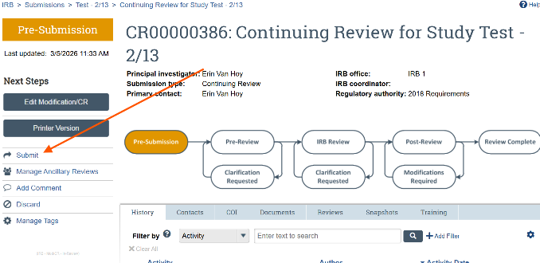
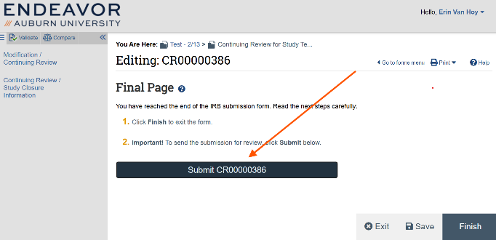

- How to Submit items in Endeavor: After initial submission to the IRB, when responding to an IRB clarification request, you must use the “Submit Response” button on the “Next Steps” menu of the submission workspace (see snips below):
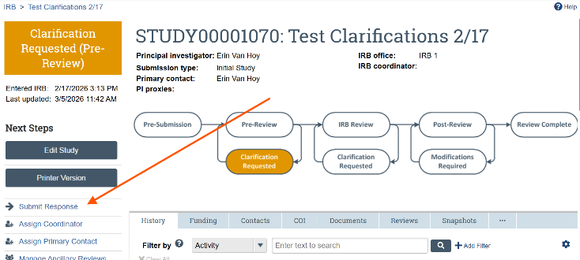

- Resources: You have a wealth of resources to aid in your research, “Endeavor” – see below for an abbreviated list of what’s available:
  - Endeavor Library:
    - Human Research Protection Program Plan (HRP-101)
    - Investigator Manual (HRP-103)
    - Templates: Protocol Templates, Information Letters, Consent Forms, etc.
    - IRB Office Contact List
  - Help Center:
    - Guidance on how to create a new study submission
    - Guide for researchers that includes how to submit modifications, continuing reviews, and new information reports, as well as how to respond to clarifications.
    - Guide for updating your shell protocol (for studies that migrated from SharePoint to Endeavor).

QUESTIONS?
Please reach out to your AU IRB team at IRBAdmin@auburn.edu

