
HRPP Newsletter

March 2025



NEWS YOU CAN USE
- Do you have questions about the AU IRB team and goals of the co-sourcing project? Please see the IRB Introduction presentation for more information.

- Have you reviewed the Investigator Manual? This document provides an overview of how to prepare and manage submissions throughout the life of the study and provides helpful information about additional regulatory requirements that may relate to a study. The Investigator Manual is a great resource when you have questions about the IRB submission process.

- The IRB staff are assessing templates and appendices to identify areas where we can improve on the informaiton requested in these materials. For example, we are planning to omit appendices in favor of building out sections in the protocol templates. Please provide feedback to IRBAdmin@auburn.edu if there are sections of the protocol templates that could benefit from improved instruction.

- The HRPP Toolkit and Endeavor IRB systems were launched in August 2024. The IRB office will need all currently-approved studies to update their “shell protocol” in Endeavor at the time of first touch (whether modification or continuing review) or by August 29, 2025, whichever comes first.
  - The OVPR is developing an approach to update records for studies that do not required annual review, and there are no planned modifications. OVPR will be reaching out to study teams to determine the status of these studies. Stay tuned for more information on this initiative!

WHAT’S NEW?
- HRP-904 – Appendix – Department Ancillary Review, is no longer required as an attachment when completing departmental review. Instead, Department Review is managed within Endeavor. The research teams will be asked to use the “Manage Ancillary Review” activity to assign your Department Head before initial submission of a new study. Please see HRP-309 – Worksheet – Ancillary Review Matrix for information about ancillary reviews that may be requried for your submission.
- The following approval statement is no longer required to be applied to consent and/or recruitment documents: “The Auburn University Institutional Review Board has reviewed this study. Protocol #STUDY00000xxx”.
- If your study includes surveys, the platform-specific printout is no longer required. It is sufficient to upload the survey questions as a Word document.

- Beginning in April 2025, the IRB will begin assigning three-year approval periods to studies that do not require annual review. The goal is to ensure that studies are closed and provide a more accurate account of ongoing research at Auburn. Studies with the three-year approval periods may be renewed if the study is not completed by the indicated expiration date.

ENDEAVOR TIPS & TRICKS
- Have you ever wondered why the IRB has not started to review your submission? Remember to double-check that you have selected the option to “Submit” as the last step when you are ready for the IRB to review your new submission or when you are responding to clarification or modification requests.
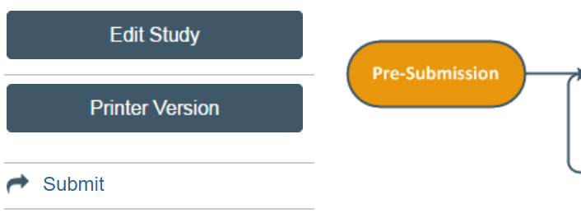

- Please avoid submitting documents as PDFs in the Endeavor system (unless no other format is available). The IRB needs to review documents in MS Word format so we can use functionality in the system to identify changes made to these materials.
  - We will accept PDFs of the compiled, previously approved study documents, as an attachment in the “Local Site Documents” page when updating the shell record. However, these documents are submitted in addition to the protocol and other attachments being uploaded in the Endeavor system on the appropriate smartform pages as MS Word documents.

- When the IRB requests changes to a submission, please do not delete attachments. Instead, use the “Update” button to the left of the document that is revised and upload the revised version. This allows the IRB to compare the submitted documents and retains all reviewed materials as part of the audit trail.
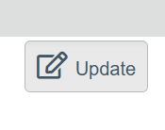
- Using the “Track Changes” function in MS Word helps the IRB to quickly identify changes you make to your submissions when responding to modifications or clarifications requested from the IRB. You can turn “Track Changes” on by going to Review > Track Changes in MS Word. Don’t worry, Endeavor cleans-up the tracked changes when the IRB approves the final versions of each document.

- Endeavor User Guides are available in the “Help Center” and can be a good reference tool when getting familiar with the system.

QUESTIONS?
Please reach out to your AU IRB Team!

