

HRPP Newsletter

June 2025



NEWS YOU CAN USE
- The IRB staff hosted a virtual training on the IRB submission process in the Endeavor system. The training covered how to submit a new study, respond to requests from the IRB, and how to create follow-on submissions (Continuing Reviews, Modifications, Reportable Events, and Closures). The focus is on system functionality and tips for managing your submissions.
  - Link to training: Endeavor Demo - Single Site Submissions

- If your study involves external collaborators from a site that does not have an Institutional Review Board, please follow the instructions below to add these collaborators as individual investigators. Note, this guidance is not applicable to collaborations with investigators affiliated with instituitons that have their own IRB.

Upload a word document with the following information for each external individual:
    - Name, title
    - Institution
    - Role on study
  - Ensure they have complete and up-to-date AU-required CITI trainings:
    - IRB #1 Health Sciences” OR “IRB #2 Social and Behavioral Emphasis - AU Personnel - Basic/Refresher
    - AU Basic RCR Training for ALL Faculty, Staff, Postdocs, and Students
    - FOR RESEARCH WITH MINORS:
      - Research with Children – SBE – Basic Course (ID 507) OR Vulnerable Subjects – Research with Minors (ID 9)
      - Auburn University’s Youth Protection Program Training (available in ElevatED) (CR506E) or through the AU Youth Protection Program Portal.
  - To affiliate with Auburn as an external collaborator on the CITI website with an existing account, follow the graphic below.
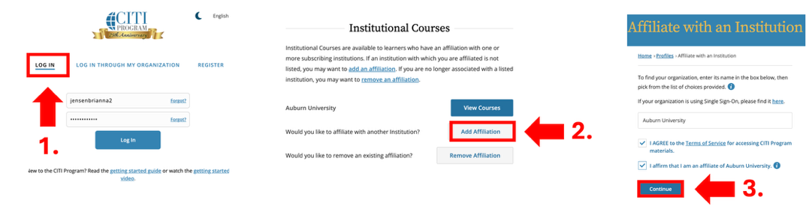

- To affiliate with Auburn as an external collaborator on the CITI website without an existing account, follow the graphic below.

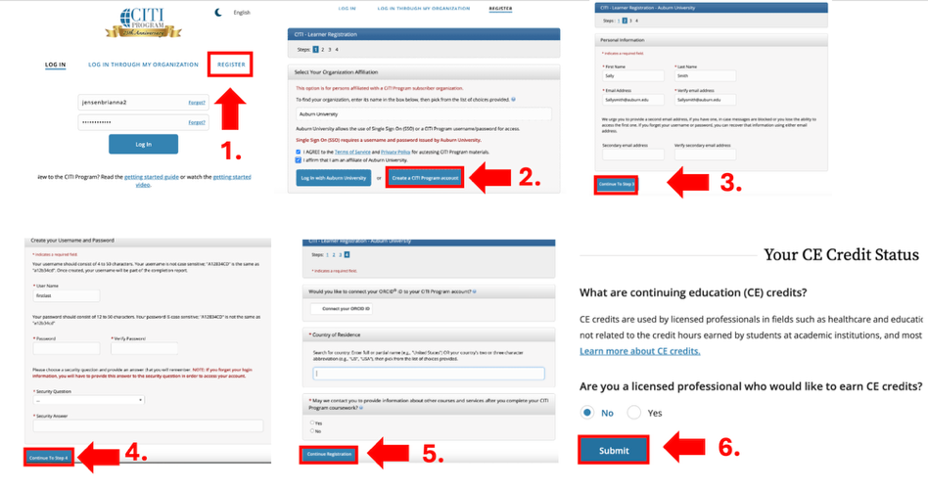
- Enhanced AU Registrar Review Process: We are excited to announce an update to our process for reviewing studies that involve the use of Auburn University Student Records. HRP-309 - WORKSHEET - Ancillary Review Matrix has been updated to outline a revised AU Registrar review process that is conducted directly within the Endeavor system, eliminating the need for external email communications. This change allows study teams to assign the Registrar as an ancilary at the time of review which streamlines the workflow, enhances transparency, and ensures all reviews of studies using AU student records and FERPA requirements (HRP-331 - WORKSHEET - FERPA Compliance) are efficiently tracked and managed within Endeavor.
Key Benefits:
  - Centralized Review Process: All reviews will be conducted and documented within Endeavor, providing a single source of truth.
  - Improved Efficiency: Reducing reliance on email communications will speed up the review process and minimize delays.
  - Enhanced Transparency: Stakeholders can easily access and monitor review statuses within the system.
We believe this update will significantly improve our review process and look forward to your cooperation in implementing these changes.

WHAT’S NEW?
- The HRPP Toolkit materials were updated to reflect shifts in regulations, guidance from federal agencies, and alignment with industy best practices. Plese remember to always access the Endeavor Library for the current versions of all HRPP Toolkit materials.

ENDEAVOR TIPS & TRICKS
- Did you know that where you place documents in the Endeavor system matters? Please place only protocol documents in the “Protocol” section of the application and attach other supporting materials on the “Local Site Documents” page in the appropriate section.

When updating documents in Endeavor do not delete previously submitted versions and do not submit PDFs. Instead, use the “update” button to upload a new version of the document that you revised.

QUESTIONS?
Please reach out to your AU IRB Team!

