

HRPP Newsletter

July 2025



COMING SOON
- To minimize the need for multiple templates and streamline information requested in IRB protocols, the IRB plans to release a revised version of HRP-503. Be on the lookout for an announcment when the new template is released (expected August 2025).
- The IRB is standardizing the consent templates, which will be required for use with submissions. The IRB also plans to require use of the protocol template(s). Be on the lookout for announcements on when materials will be required for use, which will include a grace period for submissions prepared before the revised templates were available.

NEWS YOU CAN USE
- Did you know that your research protocol is not only for IRB review? A well-written research protocol is the cornerstone of any successful study. It serves as a detailed roadmap that guides the research process, ensuring clarity and consistency from start to finish. By clearly outlining the objectives, methodology, and procedures, a comprehensive protocol helps prevent misunderstandings and errors, facilitates smooth collaboration among team members, and enhances the credibility of your research. Moreover, a meticulously prepared protocol is often crucial for obtaining funding, as it demonstrates thorough planning and adherence to regulatory standards. Investing time in crafting a clear and detailed research protocol ultimately saves time, minimizes opportunties for error, and increases the the potential for achieving meaningful and reliable research results.
- Reminder: Department review should be added by the study team prior to submission. This involves clicking the “Manage Ancillary Reviews” button and adding your department chair. Instructions for adding ancillary reviews are below
- Enhanced AU Registrar Review Process: We are excited to announce an update to our process for reviewing studies that involve the use of Auburn University Student Records. HRP-309 - WORKSHEET - Ancillary Review Matrix has been updated to outline a revised AU Registrar review process that is conducted directly within the Endeavor system, eliminating the need for external email communications. This change allows study teams to assign the Registrar as an ancillary at the time of review which streamlines the workflow, enhances transparency, and ensures all reviews of studies using AU student records and FERPA requirements (HRP-331 - WORKSHEET - FERPA Compliance) are efficiently tracked and managed within Endeavor.
Key Benefits:
  - Centralized Review Process: All reviews will be conducted and documented within Endeavor, providing a single source of truth.
  - Improved Efficiency: Reducing reliance on email communications will speed up the review process and minimize delays.
  - Enhanced Transparency: Stakeholders can easily access and monitor review statuses within the system.
We believe this update will significantly improve our review process and look forward to your cooperation in implementing these changes. Instructions for adding this ancillary review are below.

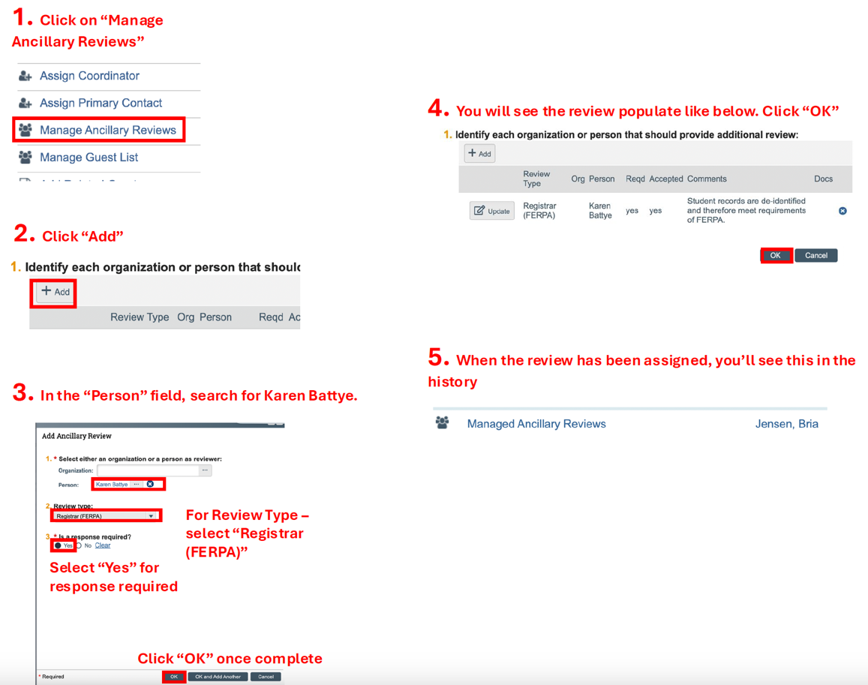

WHAT’S NEW?
- The HRPP Toolkit materials were updated to reflect shifts in regulations, guidance from federal agencies, and alignment with industy best practices. Plese remember to always access the Endeavor Library for the current versions of all HRPP Toolkit materials.

ENDEAVOR TIPS & TRICKS
- Did you know that where you place documents in the Endeavor system matters? Please place only protocol documents in the “Protocol” section of the application and attach other supporting materials on the “Local Site Documents” page in the appropriate section.

When updating documents in Endeavor do not delete previously submitted versions and do not submit PDFs. Instead, use the “update” button to upload a new version of the document that you revised.

- When submitting an updated document, use the “tracked change” feature in MS Word rather than highlighting the changes. This allows the IRB to review the updates expeditiously and get back to you with feedback or an outcome more swiftly.

QUESTIONS?
Please reach out to your AU IRB Team!

