

HRPP Newsletter

February 2026



NEWS YOU CAN USE
- Protocol Template: Now that HRP-503 - TEMPLATE PROTOCOL is required for all new human subject research studies requesting review by Auburn IRB, we have received questions about why this change was made. The decision to move toward a single protocol template, regardless of review type, was made with a few key goals in mind:
  - Streamline the submission process: Having one consistent template helps reduce confusion about which form to use, especially for researchers who may not submit frequently or are new to the process.
  - Enhance turnaround times: Minimization of rounds of review between and IRB and study teams due to use of outdated or incorrect templates that do not prompt for all necessary information.
  - Capture all necessary information upfront: Even for exempt studies, we often need similar core details to ensure compliance and appropriate review. The updated template is designed to gather that information in a more structured and complete way.

Please continue to reference the Library to find all current materials used by the AU HRPP team, as well as the most up-to-date versions of the Investigator Manual and templates used to prepare submissions.

- Under Construction Reminder: The AU HRPP/IRB website is undergoing maintenance. Please remember to check the Endeavor Library, the monthly newsletter, or contact the AU HRPP team if you are unsure about how to prepare and complete your IRB submissions.

- IRB Consultations: Are you new to Auburn University? Is this your first time submitting an IRB application? Or do you have a complex or unique study design? If you answered yes to any of these questions, an IRB consultation can help! Schedule a 30-minute meeting with an IRB Operations staff member by emailing IRBAdmin@auburn.edu.
  - Please note: Principal Investigators are required to attend all consultation meetings due to their overall responsibility for the research.

ENDEAVOR TIPS & TRICKS
- Endeavor System Reminder Emails: If you receive an email reminder indicating that your submission is awaiting a response, this means that IRB staff, reviewers, or the IRB have requested clarifications that require your attention. Please log into Endeavor to address the requested items or, if you no longer plan to move forward, withdraw or discard the submission. Please note this automated message is sent every 16 days and recorded in the Endeavor submission history as “Response Time Exceeded.” Taking timely action will help prevent delays in the review process.

- Tips for Smooth IRB Submission: To help investigators avoid unnecessary delays, IRB Operations staff review incoming submissions for completeness and compliance before pre-review. The most common reasons for the submissions being returned include the following:
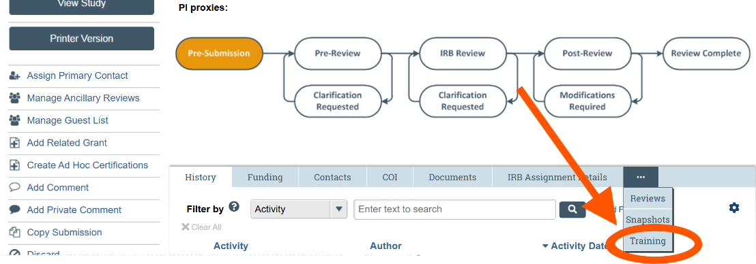
  - Required Training Not Completed or Not Current: All study personnel must complete the required human subjects training prior to submission, as outlined in the Investigator Manual. Submissions will be returned if the training is incomplete or expired. To check training for all study personnel, navigate to the “Training” tab in the study or submission workspace, as shown below.

  - Use of Outdated Protocol or Consent Templates: Investigators must use the current IRB‑approved protocol template and consent form or Information Letter templates available in the Endeavor IRB library, under the “Templates” tab. Use of outdated templates is a frequent reason for submissions being returned, as older versions may not align with current regulatory or institutional requirements.

Taking a few minutes before submission to verify training completion and confirm use of the most current templates can significantly reduce administrative revisions and help your submission move through review more efficiently. If you have questions about training requirements, template versions, or navigating Endeavor, the IRB Office is available to assist. Email us at IRBAdmin@auburn.edu.

- Updating Documents: When updating documents in Endeavor, do not delete previously submitted versions and do not submit PDFs. Instead, use the “update” button to upload a new version of the document. Additionally, use the “tracked change” feature in MS Word; please DO NOT highlight the changes. This allows the IRB to review the updates expeditiously and get back to you with feedback or an outcome more swiftly.

- Resources: You have a wealth of resources to aid in your research, “Endeavor” – see below for an abbreviated list of what’s available:
  - Endeavor Library:
    - Human Research Protection Program Plan (HRP-101)
    - Investigator Manual (HRP-103)
    - Templates: Protocol Templates, Information Letters, Consent Forms, etc.
    - IRB Office Contact List
  - Help Center:
    - Guidance on how to create a new study submission
    - Guide for researchers that includes how to submit modifications, continuing reviews, and new information reports, as well as how to respond to clarifications.
    - Guide for updating your shell protocol (for studies that migrated from SharePoint to Endeavor).

QUESTIONS?
Please reach out to your AU IRB team at IRBAdmin@auburn.edu

