
HRPP Newsletter

April 2026



NEWS YOU CAN USE

IRB Review Timelines - What Actually Drives Them? A common question we receive is: “How long will the IRB review take?” While every study is different, IRB review timelines are typically influenced by several key factors:

What can impact review time?
  - Submission volume: At times of high submission volume (e.g., start of a semester, grant deadlines, or course-related submissions), review timelines may be affected as studies are processed in the order received.
  - Completeness of the submission: Missing sections, inconsistent information, or incomplete study documents often require follow-up before review can proceed.
  - Clarity of the protocol and consent materials: Clear, well-organized descriptions of procedures, risks, and participant protections allow reviewers to complete their review more efficiently.
  - Study complexity: Studies involving vulnerable populations, sensitive data, biological samples, devices, external collaborators, or performance-based compensation may require additional review considerations.
  - Ancillary reviews: Some studies must undergo additional reviews (e.g., biosafety, FERPA, Department review, etc.) before IRB approval can be finalized.
  - Responsiveness to stipulations: Timely and complete responses to IRB requests help prevent unnecessary delays.

What can researchers do to help?
  - Use current IRB templates and guidance documents located in the Endeavor Library.
  - Ensure all study materials are consistent before submitting.
  - Reach out to the IRB early—consultations are available and encouraged.
  - Respond to IRB feedback using tracked changes and clear explanations.

The IRB’s goal is to conduct a thorough and timely review while ensuring the rights and welfare of research participants are protected and regulations are abided. Early planning, clear submissions, and awareness of peak submission periods can go a long way toward keeping studies moving forward.

Before You Recruit, Survey, or Interview—Check with the IRB: Under federal regulations and institutional policy, IRB review and approval (or an exemption determination) must occur before any research activities are initiated. This includes activities that may feel preliminary or low‑risk, such as:

  - Recruiting or contacting potential participants
  - Distributing flyers, emails, or recruitment messages
  - Screening individuals for eligibility
  - Collecting data (including surveys, interviews, or observations)
  - Accessing identifiable private information for research purposes

If you are unsure whether a planned activity constitutes human subjects research or requires IRB review, contact the IRB Office before proceeding— asking early can save time and prevent unintended compliance issues. Once research activities have occurred without prior IRB review, there is no mechanism for the IRB to retroactively approve or exempt the research.

ENDEAVOR TIPS & TRICKS
Compare Feature: Did you know that Endeavor has built-in functionality to allow researchers and IRB reviewers to compare versions of submitted documents? This feature works when you’ve submitted a Response to Clarifications Requested, Response to Modifications Required, or a Modification. See the screenshots below on how to use this Endeavor function.

Click View Study in the Next Steps menu.
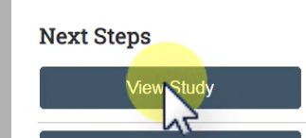

Click “Compare”.

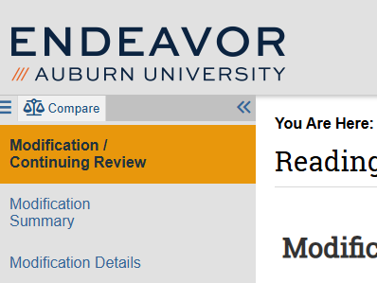

The pencil icon tells you there was a change made to that section of the application. For any document with a revised version, the “compare” button will be available.

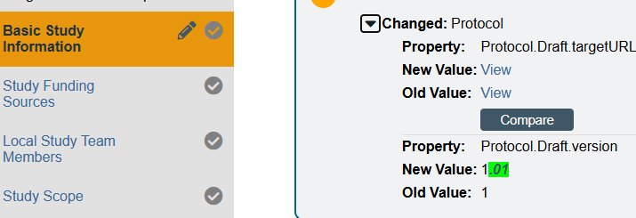

Endeavor Help Text: Endeavor has help text built in to support researchers when submitting their IRB application. Click the question bubble for pop-up help text about that field.



Resources: You have a wealth of resources to aid in your research, “Endeavor” – see below for an abbreviated list of what’s available:
  - Endeavor Library:
    - Human Research Protection Program Plan (HRP-101)
    - Investigator Manual (HRP-103)
    - Templates: Protocol Templates, Information Letters, Consent Forms, etc.
    - IRB Office Contact List
  - Help Center:
    - Guidance on how to create a new study submission
    - Guide for researchers that includes how to submit modifications, continuing reviews, and new information reports, as well as how to respond to clarifications.
    - Guide for updating your shell protocol (for studies that migrated from SharePoint to Endeavor).

QUESTIONS?
Please reach out to your AU IRB team at IRBAdmin@auburn.edu

